NEW LEGISLATION ON CLIMATE CHANGE REPORTING REQUIREMENTS FOR PUBLIC BODIES IN NORTHERN IRELAND

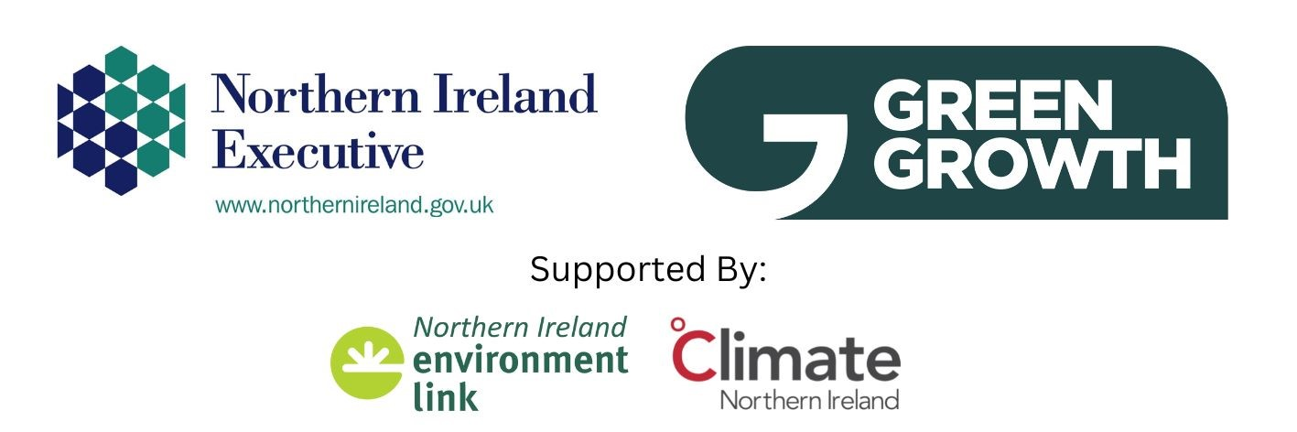

PRECONSULTATION EXCERCISE: Further feedback form

Below are questions to assist you providing your organisation’s views and feedback as part of DAERA’s pre-consultation exercise to help inform the development of the above new upcoming regulations, and the associated public consultation to be undertaken in early 2023.
Please note when considering the below questions, it would be useful to consider the supporting information provided at this hyperlink which includes the pre-consultation workshop presentations, the example of a draft template of potential questions which could be asked under a climate change reporting duty, and the other supporting information documents.

Name___________ Organisation_______________

Contact Details__________________________________________________________

FEEDBACK QUESTIONS

SECTION 1 – WHAT IS YOUR ORGANISATION DOING ALREADY (EXISTING PRACTICE – POLICY & REPORTING)
- Is your organisation currently implementing any other measures to mitigate (i.e. reduce emissions) or adapt to climate change?

- If your organisation is already measuring and reporting on climate change, is it an internal initiative or part of an external reporting regime? (If it is an external regime please tell us the name of that reporting regime.)

SECTION 2 – DRAFT REPORTING TEMPLATE – WHAT REPORTING QUESTIONS COULD LOOK LIKE
An example of a draft template of questions that may be required to be completed under the upcoming new regulations as part of a public body climate change reporting duty can be found here: Example of a potential climate change reporting questions template.

- Please provide your orgnaisation’s feedback/comments in relation to the template’s four main headings set out below.
Draft template headings:
  - Part 1: Profile of Reporting Organisation

  - Part 2: Climate Change Management & Governance

  - Part 3: Adaptation: Climate Change Risk Assessments, Adaptation Action Plans & Progress

  - Part 4: Mitigation: Emissions Statements & Emissions reduction plans and Progress

- How are the above headings (part 1-4) and the potential questions under each heading in the draft template relevant to your organisation, and could your organisation answer the questions?
- Are there any questions or topics missing in the draft template? If so, what are they?
- Is there too much or too little detail in the draft template? If so, please explain.

SECTION 3 - ADDITIONAL INFORMATION TO HELP INFORM THE CONTENT OF THE REGULATIONS
Please provide feedback on:
- Do you think reporting should be mandatory, voluntary or a mix of both?

- Who do you think should be required to report (i.e. who should be specified under the regulations)?

- What criteria do you think should be considered to identify or define who should be required to report? (e.g. size of public body – staff, assets, etc.)

- When do you think the first reports should be required to be provided, and how often do you think organisations should report?

- Any other comments on the timing of when reports should be submitted? e.g. a particular month of a given reporting year(s).

SECTION 4 – SUPPORT REQUIRED AND USE OF THE INFORMATION
- What types of support might be needed, to help your council and other public bodies to report (e.g. data gathering, guidance, training)?

- How would you like to see the information collected being used?

SECTION 5 - ANY ADDITIONAL POINTS/QUERIES
- Do you have any additional points to raise within the scope of section 42 which were not covered in the above questions?

- Do you have any specific questions about the new upcoming regulations or their development which is not currently covered in the supporting documentation found at this hyperlink?

Thank you for your feedback. Please email to PBR@climatenorthernireland.org.uk

